|  |  |
| --- | --- |
|  | |
| **Welcome to ‘The Pulse’** | **The Pulse**  “The heart of God  to the heart of the community”  **July 2017 Issue** |

The Pulse is a quarterly newsletter produced by the Ellesmere Cooperating Parish. We are three congregations that make up a rural parish in the south-eastern part of the Selwyn District of Canterbury, NZ.

Our three congregations, Leeston, Dunsandel and Brookside, draw people from all walks of life, with a high proportion involved in farming or associated services. Our Brookside congregation has shared use of St. Luke's Anglican Church at Brookside.

**Purpose Statement:** To spread the good news of Jesus by committing ourselves to work and worship together, to love and care for one another, and to be of value to God in our community.

To find out more about the Ellesmere Cooperating Parish, please take the time to visit us on line at [www.churchatellesmere.org.nz](http://www.churchatellesmere.org.nz/)

We hope you enjoy this issue of The Pulse.

Your newsletter was delivered by:

…………………………………………………………….

Phone: …………………………..............................

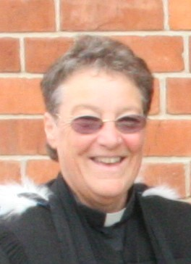**Reflection from Rev. Heather Kennedy**

At the recent Day of Fellowship held in St. David’s foyer, more than thirty members of the parish attended for most of the day. Starting with fellowship over morning tea, then a guided discussion, followed by a shared lunch in the Hall, thanks to all who brought contributions. This was followed by more time in discussion and input from Rev. Kathryn Walters, concluding with afternoon tea.

Among the topics discussed in the morning session were:

* Changes in society, the rural sector and satellite towns, which could provide untapped potential and enjoyable opportunities.
* The impact of everyone’s mobility, which provides more choices, on church membership and Sunday service attendance.
* How fear, anxiety and stress affect our sense of unease when situations change.
* How resistance to change can create a lack of stability and disagreements.

This led on to a general discussion of many aspects of the parish that people wanted to highlight. Some of the key words that come up were:

* the demographic of our community which is multi-cultural, which is not evident in the parish. There is little cross-fertilisation of congregations in the parish, especially with the Life Touch Filipino community
* the variety of choices people have for their free-time and a preference for making the most of opportunities
* elements that hinder growth in the parish, such as sentimentality and nostalgia, lost dreams, aging membership, as well as ageism (where those who are younger are given less opportunity), different values, intolerance, controlling structures and a lack of communication
* a ‘silo’ mentality (were issues are compartmentalised) was mooted as a significant stumbling block to progress.
* many ways in which change could be considered, such as being more welcoming, more tolerant, open-minded and accepting, listening to each other, having more variety in our worship, of building a sense of expectation and reaching out in mission
* as sense of complacency or accepting the status quo as being okay was also identified
* the plan to build onto St. David’s church needs to be re-visited
* a need to be charitable in supporting each other with love, graciousness and compassion

It was felt that through dialogue and discernment some of these issues could be explored further, which would be helpful for identifying areas of possibilities for shared ministry and future projects in the parish. A further meeting is scheduled for Saturday, 23rd September – details later.

In the afternoon session most of the discussion focussed on aspects of Leadership, which was acknowledged to be ‘of God’ to give life to the Parish.

The key aspects of leadership are those of guiding and direction, servanthood, encouragement and involvement in mission. Some leaders will be involved in such roles as children or youth ministry, small group leadership, supporting overseas mission, in aged care, in schools, in providing pastoral care and in working with immigrants and under-privileged groups in the community. Some leaders may have gifts and talents they could share, by leading worship, offering prayers or preaching.

Leaders should be looking for and discerning the talents of potential leaders, nurturing and resourcing each other and planning for handing on to successors. All leaders should be recognised for the role they play in the life of the parish and this could be observed each year in a Covenant Service (often held at the beginning of February).

It was also identified that we do not affirm our faith in a recognised way very often, so an Affirmation of Faith could be included in some worship services.

Then Rev. Kathryn Walters outlined the time-line for the Methodist Stationing process for next year.

The main task is for the parish to identify ‘who we are’, with reference to all that we had been discussing, and ‘who we are wanting to be’. This information will help with the process of matching our parish with a minister most suited for the parish.

Between March and May 2018, a fresh Parish Profile needs to be compiled to truthfully provide the detailed information required. This is like writing up a CV for the parish. This also needs to include information on the direction the parish wishes to be progressing towards, in order to be matched with a suitable person to assist with the parish to do this. The membership roll of the parish also needs to be brought up-to-date, so this task will be undertaken in the near future.

In July, the parishes requiring a minister are compared with the profiles of the minister who are available for stationing. Gifts, talents and skill-sets are considered and matches are identified.

Hopefully, in September the parish will be matched with a minister, which will lead to a ‘face to face’ meeting in October. If everyone likes each other, then the process is completed and a new minister will be appointed to commence early February 2019.

**Afternoon tea ended the ‘Day of Fellowship’**

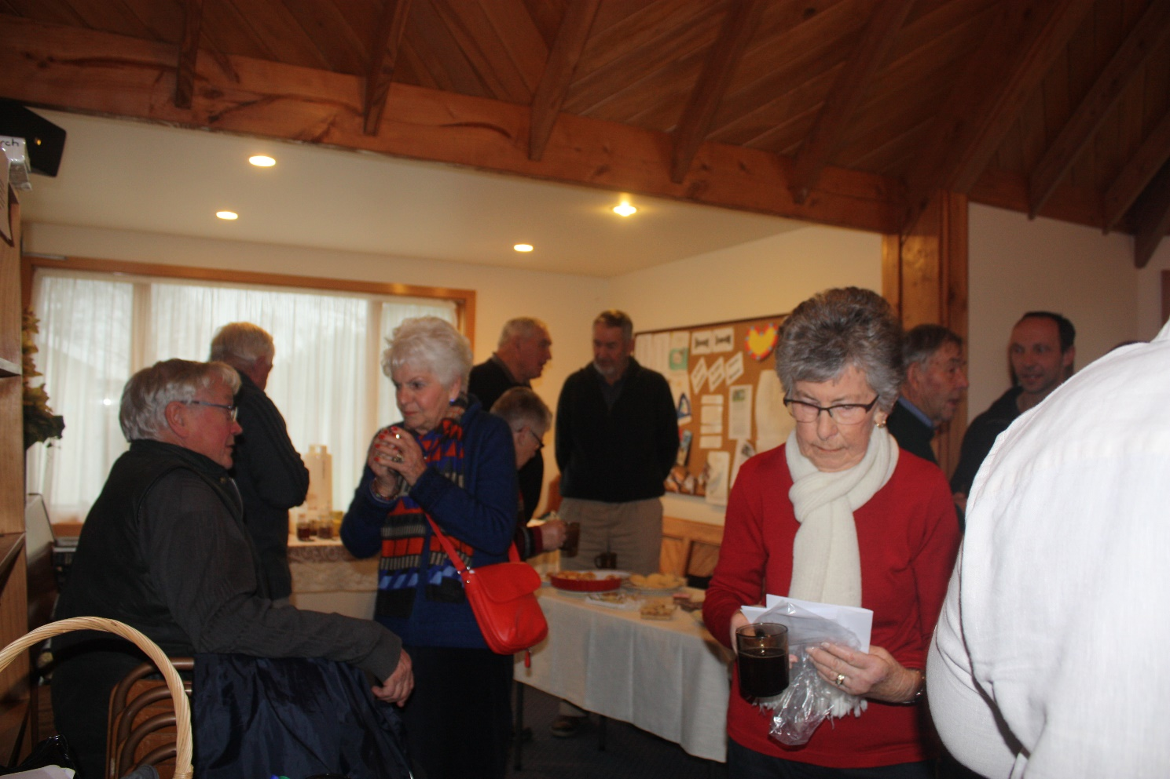

**Parish Council Report from Rev. Heather Kennedy**

As my report at the June Parish Council meeting was given verbally I now present a written version.

Throughout the month of June, I have been encouraging people to attend the Parish Day of Fellowship on July 1 at St. David’s. I have helped people understand the purpose of the day, given an outline of the programme and invited everyone to come and share stories, listen to each other, think of possibilities for the future and to hear from Rev. Kathryn Walters, what the plans are for the Methodist Stationing Process in 2018.

All members of Leeston and Dunsandel Sector committees and Parish Council as well as members of the parish are urged to attend. Lunch will be a pot-luck shared meal in the Hall.

Jim and I attended the Presbytery Retreat at Hanmer Springs from Sunday afternoon to Tuesday afternoon, 11-13 June. This was a time of networking with others in Ministry, being resourced and chilling out (or soaking in the Hot Pools, actually). The Guest Speaker was Rev. Dr. Carolyn Kelly, the Ecumenical Chaplain at Auckland University. Her insights into finding success as a result of failure, within her role was insightful and encouraging. She also shared relevant material from her doctoral research on the Reformation – highlighting the fact that nothing happens in one instant as there is always a lead-up to an event and consequences. This was particularly so with the nailing of his ‘95 Theses’ on the door of All Saint’s Church in Wittenberg by Martin Luther in 1517. (Note: 500 years ago.) He acted out of sheer frustration with the extortionist practices of the Church, never expecting the outcome that became the birth of Protestantism. A quote from him says ‘*Even if I knew that tomorrow the world would go to pieces, I would still plant my apple tree.’*

I am sure that all of us who gathered for the ‘Fish and Chip’ Tea will agree that a good night was had by all. The entertainment and the parade of fashions from The Shed, hit the right note. To end the night with some singing and Auld Lang Syne certainly topped it all off in style. Thanks go to all who provided items by talking, reciting, drama and singing, and to all who dressed up in garments from The Shed to show us all the wide variety of clothing available. Well done everyone and especially Kath and her team who presented the Fashion Parade.

I was privileged to provide a Funeral Service from Pam Tod and meet with her family and friends. She had certainly been a strong influence in many people’s lives.

I have been able to attend some of the prayer group meetings as well as attending Life Touch services.

It is good to see that John Titlow is slowly recovering from his short trip to hospital and to have him participating in the life of the parish.

While Jim and I are away on holiday in Australia for three weeks from Friday 21 July, Rev. John Titlow will be filling in for me at St. David’s on Sunday 23 July and Sunday 6 August. Rev. Don Clearwater is filling in for me at Dunsandel on Sunday 6 August. The Combined Parish Service at Dunsandel on Sunday 30 July will be led by Bruce Morriss who is the Engagement Manager (South Island) for Tear Fund.

We are looking forward to enjoying some warmer weather – hopefully, and spending time with my Mum and friends from Palmerston North, all of whom will be holidaying with us.

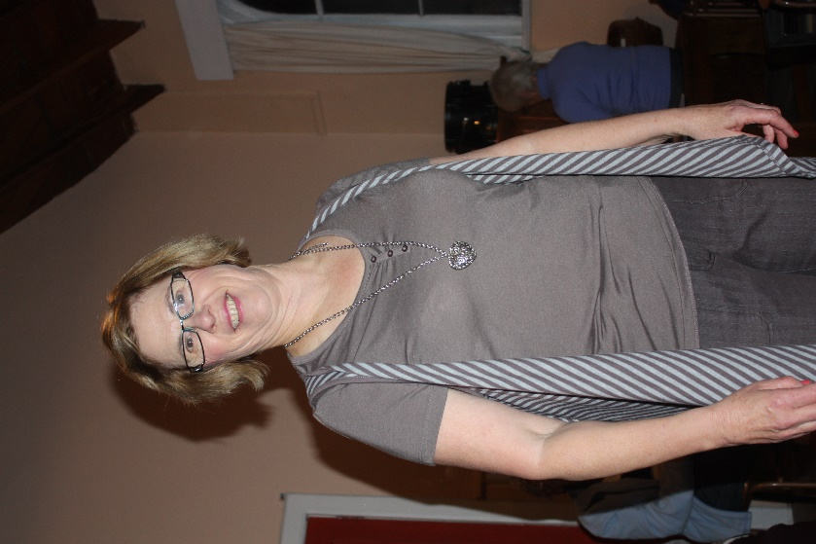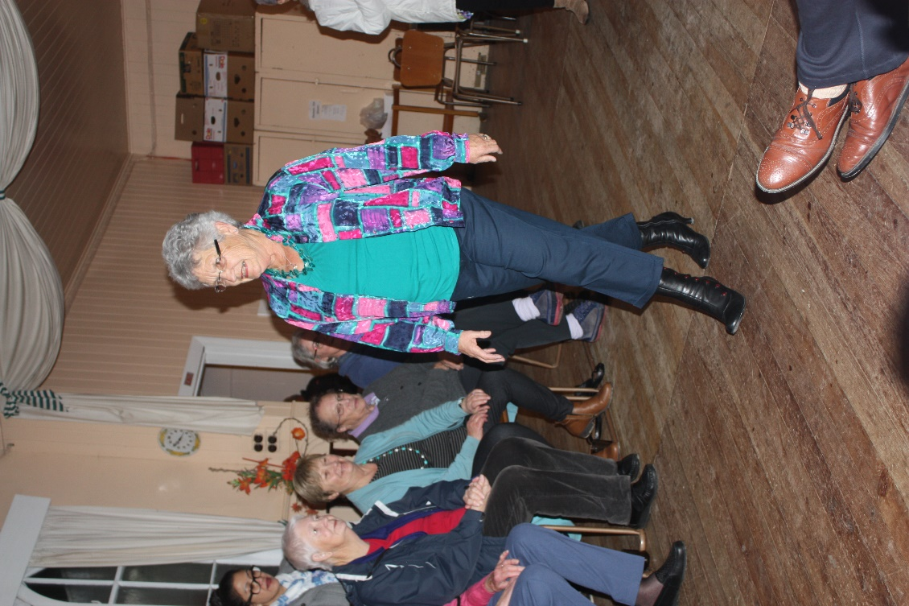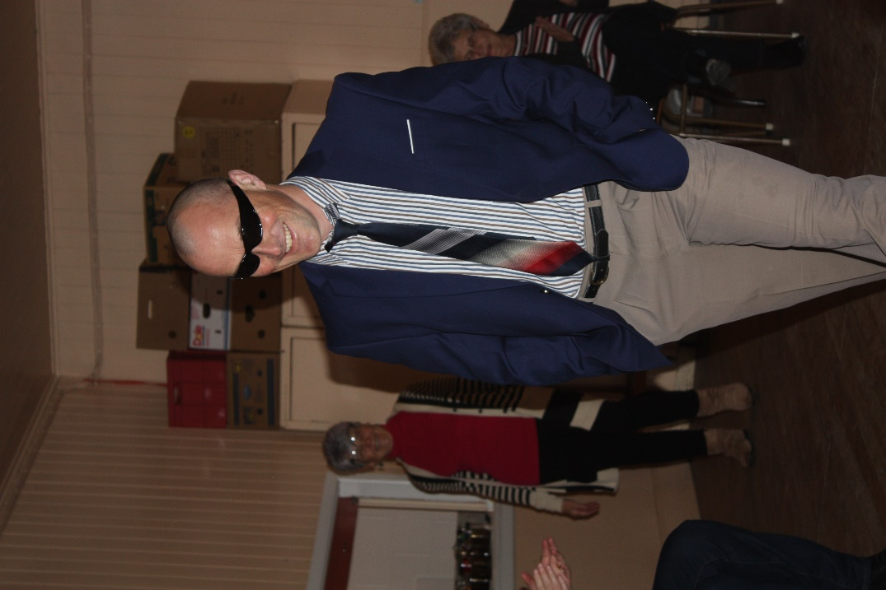The Parish AGM will be held at Leeston on Thursday 24 August at 7.30pm. The Guest Speaker will be Rev. Wyatt Butcher, Lead Chaplain at Christchurch Hospital, President of the ANZHCA (Aotearoa NZ Hospital Chaplain’s Association and their representative on the ICHC (Interchurch Council for Hospital Chaplaincy) Trust Board. All parishioners are encouraged to the attend the AGM.

**Jenny Heslop, Gordon Wadie and Gail Schat model in the Parade**

**News from St. David’s Friendship Group.**

Our April Meeting was held at Hilary Boal’s home with Hilary leading the meeting and Devotions. Members knit and Natter had resulted in two knee rugs being completed, these to be donated to worthy Organisations/Recipients.

Jill Lemon told us about her and Peter’s trip to Nepal to attend a Nepalese friend’s Wedding. What an occasion in the Nepalese custom, a six day event involving Jill and Peter in the preparations of Gifts, food, decorations etc, also fittings for Jill’s Pink and Gold Sari and Peter’s outfit. The Wedding guests arrived at 4pm on Saturday for the 10pm Ceremony, which continued until 3am Sunday with the Reception on the Monday. Jill’s photos showed the extent of this special family occasion, from preparation to the colourful ceremony.

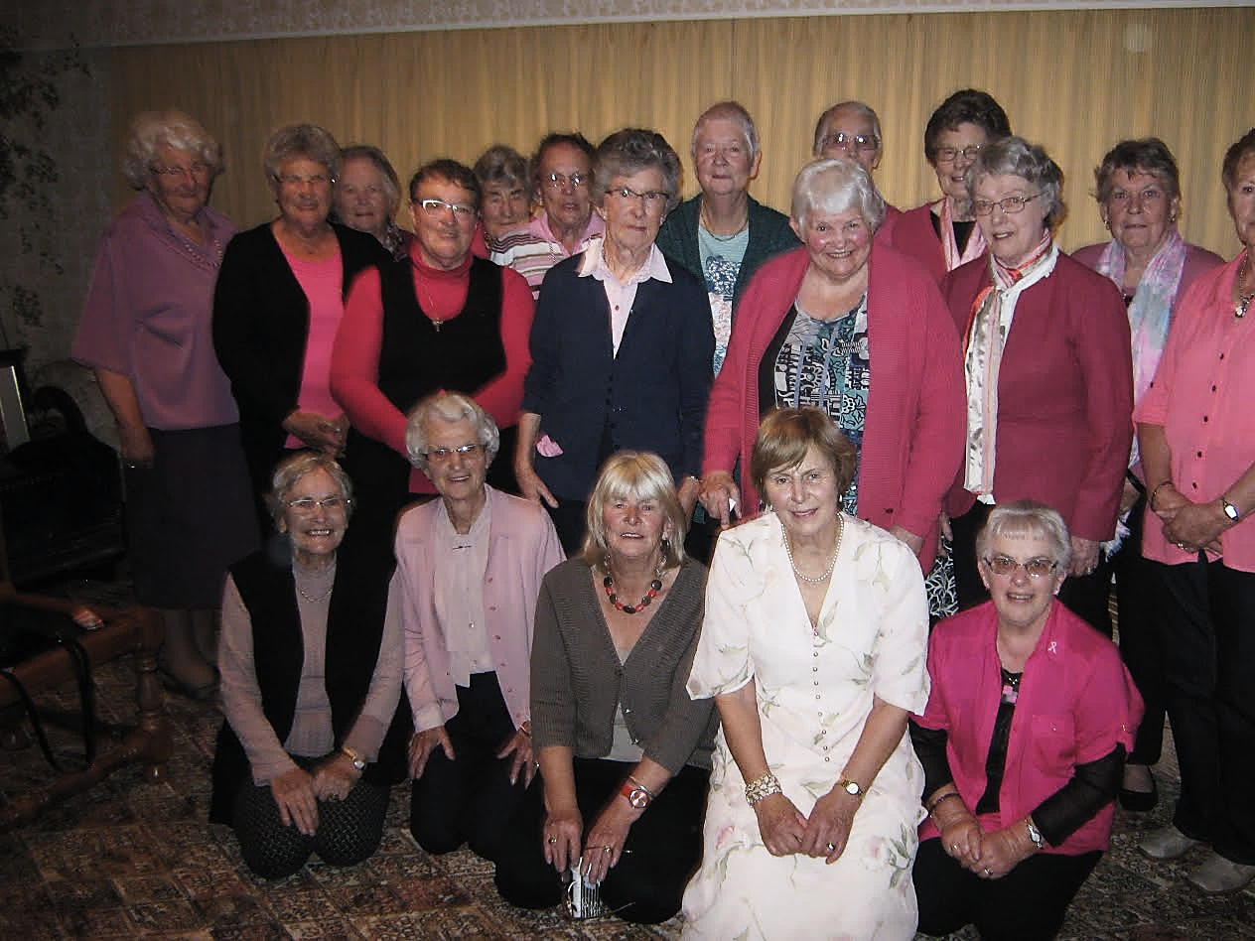In May we gathered with Afternoon Fellowship Members and friends at Jill’s home, when we dedicated our Meeting to the Pink Ribbon Appeal. We were all asked to wear something pink. Jill and Hilary had organized a social afternoon with competitions to test our memories and our agility at tearing a small sheet of paper into the longest unbroken strip of paper. A $5. Donation each, a raffle and guess the number of sweets in a jar (58) raised a total of $280.for this very worthy cause.

Jill and Hilary provided a Pink party afternoon tea, which was enjoyed by all. Thank you Jill and Hilary for organizing such a happy, friendly afternoon, while raising funds for such a worthy cause—the Pink Ribbon Appeal for Breast Cancer.

June was time again for our A.G.M. Devotions were led by Hilary entitled “Friends” with readings from Helen Steiner Rice. We enjoyed singing “What a Friend we have in Jesus” followed by Prayer remembering the Tod family in the passing of their dear Mother Pam, who was a member of our former Fellowship for many years. Following a cuppa members walked across the street to the newly opened “Lakeland Art” a very interesting Gallery and well worth a visit.

We met at Shona Nairn’s home on a sunny afternoon in July with 14 members present.

Lois lead the Meeting and Devotions, her theme “Attitudes” taken from Philippians 8:1-8 and a reading from “Word for Today”. It reminded us how Attitudes can influence our life and the life of others.

A card with Members get well messages was to be sent to Jeanette Doak who was in hospital at present.

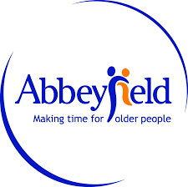Lois welcomed Jackie Cochrane who we invited to come and tell us about “AbbeyField” and its progress. Jackie heads a committee, who have worked tirelessly for several years to raise funds for furnishing the home, so far raising $140,000. The home has 14 single studio rooms with tea making facilities. Residents get their midday and evening meals prepared by the Housekeeper in a shared dining room, while they get their own breakfast in the Kitchen.

Leeston “Abbeyfield” is expected to be completed Sep/Oct with an official opening mid Nov/Dec. She has received some confirmed residents from local folk and several enquiries from people around the country interested in moving there, which augurs well for a ‘full house’ on opening. Members questions were ably answered by Jackie. Jan thanked Jackie for the formative talk and presented her with a donation to “Abbeyfield” and a small thank you gift for herself.

**News from St. David’s Fellowship Group**

In May Shirley Fisher stood in for Margaret Clearwater as Secretary. We had an enjoyable meeting with 8 members. Elaine was our speaker and gave us an interesting talk of her working life, first as an Insurance Company Employee and then as a farmer along with her husband in Leeston . Their life as farmers started the day after they moved in, when 100 ewes and 2 lambs arrived on a truck. They are still farming in Leeston. Elaine's talk was punctuated by Bible quotes about shepherds and sheep.

June was our AGM meeting and our committee gained a new Secretary after Margaret tendered her resignation. The rest of our meeting was taken up with ideas of how are group might change and also with some discussion about our programme for 2017-2018.

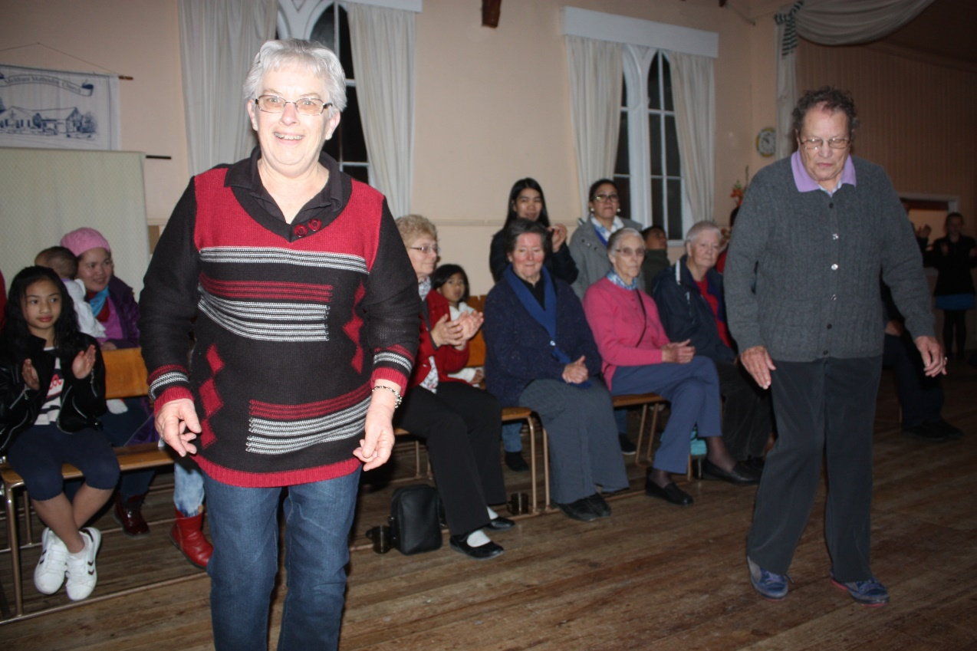

**Hilary Boal and Jan Caunter line-dancing at the Fish and Chips Social Evening.**

**‘Is God Showing Through Your Life?’**

A young girl, on the way home from church, turned to her mother and said, ‘Mummy, the minister’s sermon this morning confused me.’

The mother said, ‘Oh! Why is that?’

The girl replied, ‘Well, he said that God is bigger than we are. Is that true?’

‘Yes, that’s true.’ The mother replied.

‘He also said that God lives within us. Is that true, too?’

Again the mother replied, ‘Yes.”

‘Well,’ said the girl. ‘If God is bigger than us and lives in us, wouldn’t God show through?’

I like that young girl’s way of putting it. If God lives in us, then there is no way of keeping God from ‘showing through’. That’s the essence of Christian living in such a way that people around us will see God in our lives.

‘Let your light so shine for others, that they may see your good works and glorify your Father in heaven.’

(Matthew 5:16)

Is God showing through YOUR life?

Article supplied by Lois Birkett



***A page for the children to colour-in***



**Jesus is our friend.**

***Services & Events - July 2017 to October 2017***

|  |  |  |
| --- | --- | --- |
| **JULY 2017** |  |  |
| Sunday 16 July | 9.30am  11.00am  7.00pm | Worship Services  St. David’s, Leeston followed by  Trinity, Dunsandel (Anglican) AGM  Brookside |
| Thursday 20 July | 7.30pm | Dunsandel Sector meeting - AGM |
| Saturday 21 July | 7.30pm | Lifetouch Fellowship |
| Sunday 23 July | 9.30am  11.00am | Worship Services  St. David’s, Leeston  Café Church, Dunsandel |
| Thursday 27 July | 7.30pm | Parish Council - Leeston |
| Saturday 29 July | 7.30pm | Lifetouch Fellowship |
| Sunday 30 July | 11.00am | Combined Service at Dunsandel  Lead by – Bruce Morriss  from Tear Fund |

|  |  |  |
| --- | --- | --- |
| **AUGUST 2017** |  |  |
| Tuesday 1 August | 9.30am | Southbridge Home Group |
| Wednesday 2 August | 2.00pm | St. David’s Friendship Group |
| Thursday 3 August | 7.00pm | Men’s Group, Leeston Library |
| Sunday 6 August | 9.30 am  11.00am  5.00pm  7.00pm | Communion Services  St. David’s, Leeston followed by Congregational Meeting  Trinity, Dunsandel  Pizza Café at St. David’s  Brookside Service (Anglican) |
| Thursday 10 August | 2.00pm  7.30pm | Trinity Fellowship – Visitor’s Day  Rev. Heather Kennedy speaking Leeston Sector Meeting AGM |
| Saturday 12 August | 7.30pm | Lifetouch Fellowship |
| Sunday 13 August | 9.30 am  11.00 am | Worship Services  St. David’s, Leeston  Soup Sunday Lunch after morning tea  Trinity, Dunsandel – Rev. Kathryn  Walters |
| Thursday 17 August | 7.30pm | Dunsandel Sector meeting |
| Saturday 19 August | 7.30 pm | Lifetouch Fellowship |
| Sunday 20 August | 9.30am  11.00am  7.00pm | Worship Services  St. David’s, Leeston  Trinity, Dunsandel (Anglican)  then Soup Sunday Lunch  Brookside |
| Thursday 24 August | 7.30pm | Parish Council AGM at Leeston  Guest Speaker – Rev. Wyatt Butcher  Chaplain at Christchurch Hospital |
| Saturday 26 August | 7.30pm | Lifetouch Fellowship |
| Sunday 27 August | 9.30am  11.00am | Worship Services  St. David’s, Leeston  Café Church at Dunsandel |

|  |  |  |
| --- | --- | --- |
| **SEPTEMBER 2017** |  |  |
| Saturday 1 September | 7.30pm | Lifetouch Fellowship |
| Sunday 3 September | 9.30 am  11.00am  5pm  7.00pm | Communion Services  St. David’s, Leeston  Trinity, Dunsandel  Youth Pizza Café  Brookside Service (Anglican) |
| Tuesday 5 September | 9.30am | Southbridge Home Group |
| Wednesday 6 September | 2.00pm | St. David’s Friendship group |
| Thursday 7 September | 7.00pm | Men’s Group, Leeston Library |
| Saturday 9 September | 7.30pm | Lifetouch Fellowship |
| Sunday 10 September  Father’s Day | 9.30 am  11.00 am | Flower Sunday Worship Services  St. David’s, Leeston  Trinity, Dunsandel |
| Thursday 14 September | 2.00pm  2.00pm  7.30pm | Trinity Women’s Fellowship,  St. David’s Afternoon Fellowship  Leeston Sector Meeting |
| Sunday 17 September | 9.30am  11.00am  7.00pm | Worship Services  St. David’s, Leeston  Trinity, Dunsandel (Anglican)  Communion service at Brookside |
| Thursday 21 September | 7.30pm | Dunsandel Sector meeting |
| Saturday 23 September | 7.30pm | Lifetouch Fellowship |
| Sunday 24 September | 9.30am  11.00am | Worship Services  St. David’s Leeston  Café Church at Dunsandel |
| Thursday 28 September | 7.30pm | Parish Council Meeting - Brookside |
| Saturday 30 September | 7.30pm | Lifetouch Fellowship |

|  |  |  |
| --- | --- | --- |
| **OCTOBER 2017** |  |  |
| Sunday 1 October  World Communion Sunday | 9.30am  11.00am  5.00pm  7.00pm | Communion Services  St. David’s, Leeston  Trinity, Dunsandel  Youth Pizza Café  Brookside (Anglican) |
| Tuesday 3 October | 9.30am | Southbridge Home group |
| Wednesday 4 October | 2.00pm | St. David’s Friendship group |
| Thursday 5 October | 7.00pm | Men’s fellowship – Leeston Library |
| Saturday 7 October | 7.30pm | Lifetouch fellowship |
| Sunday 8 October | 9.30am  11.00am | Worship Services  St. David’s Leeston  Trinity, Dunsandel – Rev. Kathryn  Walters |
| Wednesday 11 October | 2.00pm  2.00pm | St. David’s Afternoon Fellowship  Trinity Women’s Fellowship group |
| Thursday 12 October | 7.30pm | Leeston Sector meeting |
| Saturday 14 October | 7.30pm | Lifetouch Fellowship |
| Sunday 15 October | 9.30am  11.00am  7.00pm | Worship Services  St. David’s, Leeston  Trinity, Dunsandel (Anglican)  Brookside |
| Saturday 21 October | 7.30pm | Lifetouch Fellowship |
| Sunday 22 October | 9.30am  11.00am | Worship Services  St. David’s Leeston  Café Church at Dunsandel |
| Thursday 26 October | 7.30pm | Parish Council meeting - Dunsandel |
| Saturday 28 October | 7.30pm | Lifetouch Fellowship |
| Sunday 29 October | 11am | Parish Combined Worship  Trinity, Dunsandel – Guest Speaker  Presentation from CAP ‘Christians Against Poverty’ |

|  |  |  |
| --- | --- | --- |
| **NOVEMBER 2017** |  |  |
| Wednesday 1 November | 2.00pm | St. David’s Friendship group |
| Friday 3 November | 7.00pm | Men’s Fellowship group – Leeston Library Community room |
| Saturday 4 November | 7.30pm | Lifetouch Fellowship |
| Sunday 5 November | 9.30 am  11.00am  5pm  7.00pm | Communion Services  St. David’s, Leeston  Trinity, Dunsandel  Youth Pizza Café  Brookside Service (Anglican) |
| Tuesday 7 November | 9.30am | Southbridge Home Group |
| Thursday 9 November | 2.00pm  2.00pm  7.30pm | Trinity Women’s Fellowship,  St. David’s Afternoon Fellowship  Leeston Sector Meeting |
| Saturday 11 November | 7.30pm | Lifetouch Fellowship |
| Sunday 12 November | 9.30 am  11.00 am | Worship Services  St. David’s, Leeston  Trinity, Dunsandel |
| Thursday 16 November | 7.30pm | Dunsandel Sector meeting |
| Saturday 18 November | 7.30pm | Lifetouch Fellowship |
| Sunday 19 November | 9.30am  11.00am  7.00pm | Worship Services  St. David’s, Leeston  Trinity, Dunsandel (Anglican)  Brookside |
| Thursday 23 November | 7.30pm | Parish Council Meeting - Brookside |
| Saturday 25 November | 7.30pm | Lifetouch Fellowship |
| Sunday 26 November  ‘Reign of Christ’ | 9.30am  11.00am | Worship Services  St. David’s Leeston  Café Church at Dunsandel |

For all events please check for updates or alterations in the Weekly Newssheets as times and dates may change.

**Small Groups for all ages!**

|  |  |  |
| --- | --- | --- |
| **Groups for Adults** | |  |
| **Intercessory Prayer** | 7.00pm | St. David’s, Leeston, note: last Tuesday of month at Trinity Church, Dunsandel. |
| **Lydia**  **Intercessory**  **Prayer Group** | 10.00am | Friday mornings – for more information, *contact Barbara Titlow ph: 260 1762.* |
| **Southbridge Home Group** | 9.30am | 1st Tuesday of the month at Ruth’s home in Southbridge.  *Contact Janice, ph:324 8202.* |
| **St. David’s Friendship**  **Group** | 2.00pm | 1st Wednesday of the month at various homes.  *Contact Hilary, ph: 324 3823.* |
| **St. David’s**  **Afternoon**  **Fellowship** | 2.00pm | 2nd Thursday of the month at the Church.  *Contact Janice, ph: 324 8202.* |
| **Lifetouch Fellowship** | 7.30pm | Ministry for Filipino families and others.  Worship Service every Saturday. *Contact Teena, ph: 324 2240 or 021 081 62926.* |
| **The Faithful Flockers** | 7.30pm | 1st & 3rd Wednesdays at Helen & Andrew’s home, Leeston.  *Contact Helen ph: 324 3032* |
| **Trinity**  **Women’s**  **Fellowship**  **Group** | 2.00pm | 2nd Thursday of the month at Trinity Church, Dunsandel.  *Contact Mavis ph: 325 4142.* |
| **Lunch Bunch** |  | A Dunsandel Trinity initiative – 1st Thursday of the month at various local eateries.  *Contact Mavis ph: 325 4142.* |
| **Men’s Group** | 7.00pm | 1st Thursday of month at Community Room, Leeston Library.  *Contact Michael ph: 324 2225.* |

|  |  |  |
| --- | --- | --- |
| **Groups for Children & Youth** | | |
| **Children’s**  **Ministry “H2O”** |  | During worship each Sunday during the school term in Leeston.  *Contact Helen ph: 324 3032.* |
| **Pre-school Music** | 9.45am –  10.30am | Wednesdays at St. David’s Church Sunday School room, followed by coffee and chat for parents and caregivers.  *Contact Naomi ph: 324 4075.* |
| **Youth Pizza Café** | 5.00pm –  7.00pm | 1st Sunday of the month at St. David’s Church, Leeston.  *Contact Linda ph: 324 2166 or Kath ph:*  *324 4100.* |

|  |
| --- |
| **Deadline for next newsletter - 1 November 2017**  **Contact person - Rev. Heather Kennedy**  Please send your information by email to [rev.heather.kennedy@gmail.com](mailto:rev.heather.kennedy@gmail.com) by the deadline date. |

|  |  |
| --- | --- |
| **CONTACT DETAILS** |  |
| **Minister** | **Phone** |
| Rev. Heather Kennedy | 324 3315 |
| **Email** | rev.heather.kennedy@gmail.com |
| **Website** | [www.churchatellesmere.org.nz](http://www.churchatellesmere.org.nz/) |
| **Lifetouch Pastor** |  |
| Teena Dela Cruz | 324 2240 |
| **Senior Laypersons** |  |
| Paul Birkett | 324 3884 |
| Robbie Stewart | 325 4535 |
| **Pastoral Care** |  |
| Lois & Paul | 324 3884 |
| Janice | 324 8202 |
| Robbie | 325 4535 |
| Noel | 329 1877 |
| **School Chaplain** |  |
| Linda | 324 2166 |

